**Ideation Phase**

**Define the Problem Sta31tements**

|  |  |
| --- | --- |
| Team ID | LTVIP2025TMID51129 |
| Project Names | Toy Craft Tales: tableau’s vision into toy  manufacturer data |
| Maximum Marks | 2 Marks |

**Customer Problem Statement Template:**

Create a problem statement to understand your customer's point of view. The Customer Problem Statement template helps you focus on what matters to create experiences people will love.

A well-articulated customer problem statement allows you and your team to find the ideal solution for the challenges your customers face. Throughout the process, you’ll also be able to empathize with your customers, which helps you better understand how they perceive your product or service.

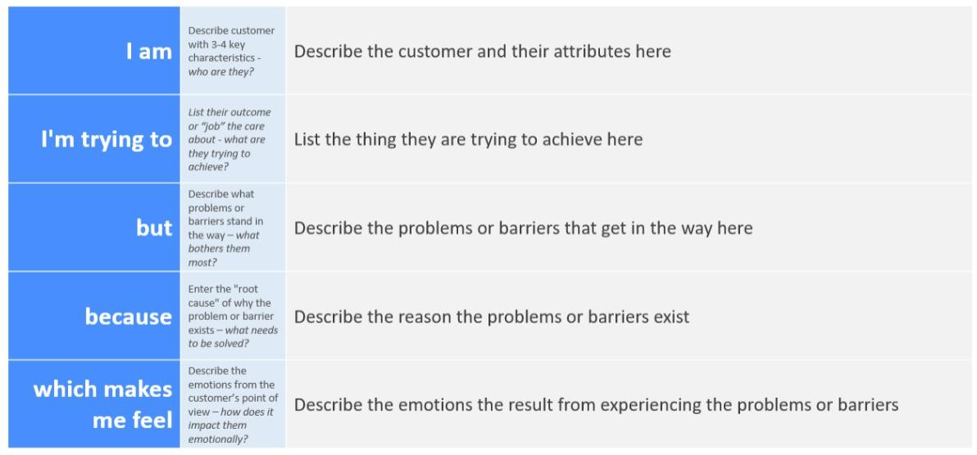

**Customer Problem statement for toy craft sales:**

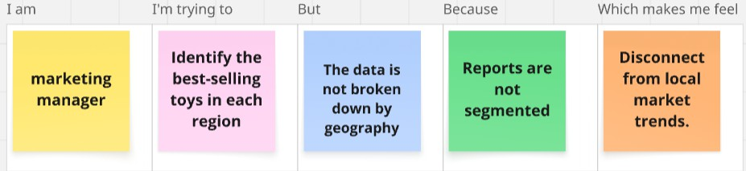

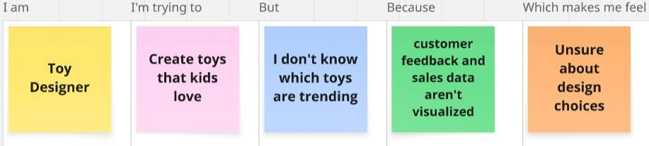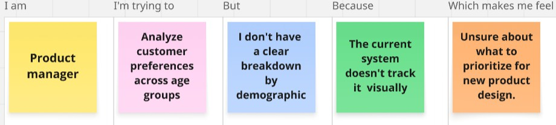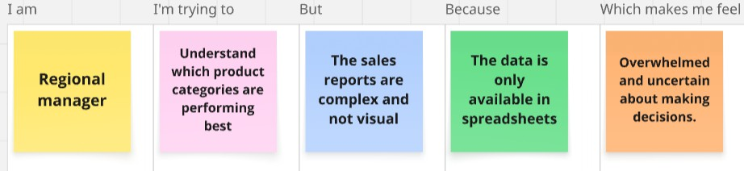

|  |  |  |  |  |  |
| --- | --- | --- | --- | --- | --- |
| **Problem**  **Statement(PS)** | **I am**  **(Customer)** | **I’m trying to** | **But** | **Because** | **Which makes me feel** |
| PS-1 | Marketing Manager | Identify the best- selling toys in each region | The data is not broken down by geography | Reports are not segmented | Disconnect from the local market trends. |
| PS-2 | Regional Manager | Understand which product categories best | The sales reports are complex and not visual | The data is only available in spreadsheets | Overwhelmed and uncertain about making decisions. |
| PS-3 | Toy Designer | Create toys that kids love | I don’t know which toys are trending | Customer feedback, sales data aren’t good | Unsure about design choices |
| PS-4 | Product Manager | Analyse  customer needs according to age | I don’t have a  clear breakdown by demographic | The current system doesn’t track it visually | Unsure about what to prioritize for new product design. |